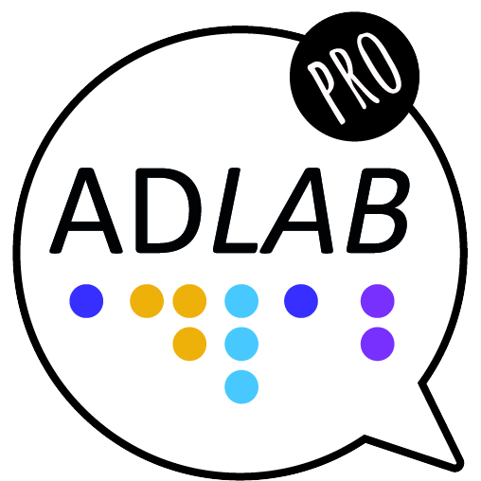

Module 5
Unit 3: Dubbing
Core video transcript
_____________________________________________________________________________

Unit 3: Dubbing 2

Module 5

Unit 3: Dubbing

Transcript
Slide 1
Hello. I’m Anna Matamala, from UAB, and in this ADLAB PRO video I will explain what dubbing is. This is Unit 3 (Dubbing) in Module 5 (Additional services).
Slide 2
Dubbing, together with subtitling and voice-over, is one of the main transfer modes when translating audiovisuals. In a dubbed product, the original voices disappear and are replaced by target language voices that talk, laugh, cry or shout as the original actors.
Slide 3
Synchronisation in dubbing is critical. It includes lip synchronisation, isochrony, and kinetic synchrony.
Slide 4
Language is very important in dubbing. Although the language of dubbing (or “dubbese”) is planned (the actors will be reading what is written), it must sound spontaneous, credible, natural. The audience needs to believe these American actors are speaking, say, Catalan. To that end, professionals use what is called a “prefabricated orality”.

Slide 5
Dubbing is the general practice in many countries. The European map that now appears on screen shows countries that only dub for children (Scandinavian countries or Portugal) and countries where dubbing is the main transfer mode (Spain, Italy, Germany or France).
Slide 6
Dubbing involves different tasks: translating the original audiovisual content, synchronising it, spotting the script (that is, segmenting the text into takes), and revising it. The output at this point is a written script. It often happens that each task is done by a different professional, but sometimes one professional can also be in charge of two or more tasks.
Slide 7
Once this written script is available, the recording with professional voice talents begins, supervised by a dubbing director. This takes place in a dubbing studio as the one on screen. There are other commercial, technical and artistic steps in the process that I will not explain.
Slide 8
In order to guarantee that the recording runs smoothly, the expert in charge of synchronisation (the dialogue writer) uses symbols. Watch the ADLAB PRO video on dubbing symbols and scripts to know more.
Slide 9
Due to synchronisation constraints, it may well be that dialogues are slightly changed. This is standard practice and should not be viewed as an instance of censorship… although it is true that dubbing has been used as a tool to censor dialogues by some regimes. Go check what happened with the translation of Mogambo in Spain, you will be surprised.
Slide 10
If you are a describer, you should always watch the content in the language the audience will receive it.
Slide 11
Also, if you are translating an AD script rather than creating it, you should be aware that the dialogues in the dubbed version may differ from the original one.
Slide 12
If you want to know more about dubbing, you can read the book “Audiovisual translation: dubbing”, by Frederic Chaume. And don’t forget to check the additional videos we’ve prepared with examples.
Creation of these training materials was supported by
ADLAB PRO (Audio Description: A Laboratory
for the Development of a New Professional Profile),
financed by the European Union under the Erasmus+ Programme,
Key Action 2 – Strategic Partnerships,
Project number: 2016-1-IT02-KA203-024311.

The information and views set out in these training materials
are those of the authors and do not necessarily reflect
the official opinion of the European Union.

Neither the European Union institutions and bodies nor any person
acting on their behalf may be held responsible for the use
which may be made of the information contained therein.

